**Smart Learning Management System (e-Edu)**

**Proposer**

M.T.D Salgado (18661) - 10707355

**Proposed supervisor**

Mr. Mohamed Shafraz

**Problem statement**

The government of Sri Lanka has used a variety of control techniques to manage the current coronavirus outbreak in the country, including social distance, quarantine, lockdowns, travel restrictions, and rural isolation. The goal of this study is to use the Internet and modern technologies to effectively address these present issues and develop viable answers. LMSs and school management systems can employ distance education as a solution.

And it is an overhead in the offline system to store instructor, student, parent, and other school staff records on paper. Everything relating to their progress in the system is carefully marked. For example, a report on a student's attendance is prepared weekly and provided to his/her parents. Now, a regular student who attends school every day is mistakenly recorded absent for one day. If I use an online platform for school education, it will be easy for both teachers and students to continue their studies.

My other goal is to cut down on paperwork as much as possible so that we don't have to cut down additional trees. In a roundabout way, I'll be assisting Mother Nature.

**Project description**

I plan to implement a Learning Management System (LMS) to solve certain current issues. Students, Teachers, and a Library Management System will be the primary components of this learning management system. These are the most challenging managerial tasks. Which they must do manually at the beginning, mid, and end of each school year.

At the end of each three-month period, management must compute student attendance, test scores, and other data, while instructors must calculate leave and compensation details for each month and year. Inventory information is also crucial; they need to know how many seats and tables are in each classroom, among other things. My system will handle library administration, such as book information and lenders' details, as well as returning and paying for late book submissions.

This school management system is intended to aid in the administration of the school.

**Project keywords**

* Java
* WordPress
* Firebase
* Android
* Sketchware

**Requirements**

Functional Requirements

Users of the LMS will use the functional LMS requirements, which are the real functionality of the LMS.

• Courses and user management.

* Exam management.
* Library access.
* Announcements & notices.

• e-Learning models.

• Creation of learning content and support.

• Report and analytics.

Technical Requirements

• Cloud-based or hosted solution.

• Security.

• Integration with other systems.

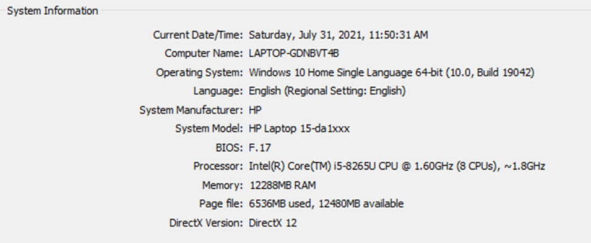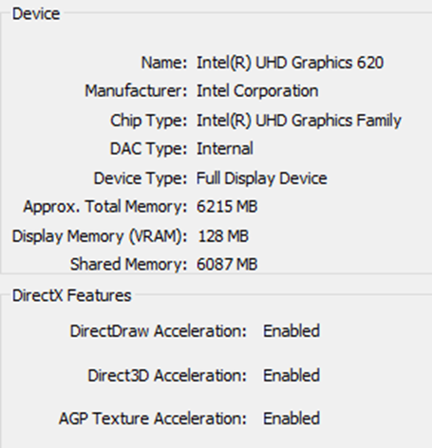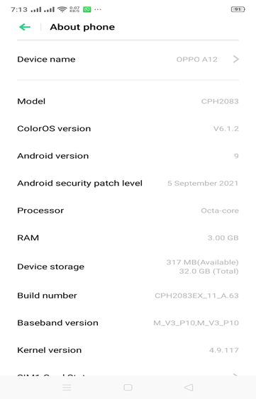

**Finance**

|  |  |  |  |
| --- | --- | --- | --- |
| Service | Monthly Price |  | Yearly Price |
| **Website**  Domain  Hosting | $ 3.67 | *12 | $ 5.98  $ 44.04 |
| **Firebase** | $ 1.62 | *12 | $ 19.44 |
| **Estimated Cost** | | | **$ 69.46** |

**External organizations**

Buddhist Girls’ College – M.T Lavinia (My Alma Mater)

**Other staff**

Supporting staff